Instructions for writing a master's thesis and doctoral dissertation

One of the aims of the dissertation is to acquaint postgraduate students with how to write and organize scientific topics.
Therefore, with a brief reference to create coordination between dissertations, we will make some points.
The dissertation is compiled in the following three main sections.
* Introductory pages
* Main text
* Appendix

*** Introductory Pages:
These pages, other than the title page, are numbered alphabetically as follows:
1. Title page: including the logo of the university (Shahid Beheshti University of Medical Sciences and Health Services), name of the university, name of the faculty, degree, thesis title, name of the supervisor, name of the consultant professor, name of the author and year of graduation.
2. Acknowledgment pages: Write a maximum of two pages.
3. Table of contents: includes the outlines of the contents in the main text.
4. List of tables: including number and title of tables.
5. List of images: including their number and title.
6. List of charts: including their number and title.
7. Abstract or summary of research in Persian (maximum 300 word).
8. Abstract or summary of research in English (maximum 300 word).
9. List of Abbreviations and their meanings
The English abstract should include the following topics:
Abstract- Title, Background & purpose, Subjects & methods, Results, Conclusion, Keywords

*** Main Text
Chapter One:
1-1 Introduction Research
1-2 Problem Statement: In this section, define the subject under study as general research with reasoned background information. What is the problem? What are the available solutions? What are the researcher's suggestions and benefits?
1-3 Necessity of Conducting Research / reasons for choosing the topic
1-4 Definitions, including: descriptive definition and operational definition of variables
1-5 Table of variables
Type of variable |  | Variable role |  |  |  | Variable scale |  |  |  |  |  | Variable name | N
Quantitative | Qualitative | independent | dependent | Intervening | Underlying | Relative | Interval | Rank | Nominal | Measurement variable | Definition of variable
 |  |  |  |  |  |  |  |  |  |  | Operational definition |  | 1
 |  |  |  |  |  |  |  |  |  |  | Operational definition
 |  |  |  |  |  |  |  |  |  |  | Operational definition |  | 2
 |  |  |  |  |  |  |  |  |  |  | Operational definition
 |  |  |  |  |  |  |  |  |  |  | Operational definition |  | 3
 |  |  |  |  |  |  |  |  |  |  | Operational definition
 |  |  |  |  |  |  |  |  |  |  | Operational definition |  | 4
 |  |  |  |  |  |  |  |  |  |  | Operational definition

1-6 Purpose of the Study
1-6-1 Objectives: general objective, specific objectives (analytical / descriptive) and practical objectives
1-6-2 Research Hypotheses / Questions

Chapter 2: A Review of the literature
Present the results of previous studies taken from information sources according to the research issue by mentioning the year of research, the name of the researcher and its country, the number of people surveyed and the result obtained.

Chapter 3: Research Methods and Techniques
3-1 Types of study
3-2 Population: including:
* Definition of the study community
* Criteria for inclusion, non-inclusion and exclusion from the study
*Sampling
* Sample size and statistical calculation method
3-3 Methods of collecting data
3-4 Data analysis methods
3-5 Ethical and Human Considerations of Study

Chapter 4: Findings
In this chapter, with complete neutrality, only the reports of the findings should be presented based on the set goals and any reasoning in this section should be avoided. It is necessary to use statistical tests in each section and determine their significance level. Avoid repeating the findings presented in tables and graphs within the text.

In the tables, the values ​​of Mean ± SD or Mean ± SE and the range along with "Min" and "MaX" are presented as R (Max-Min) for quantitative research variables and the frequency of qualitative variables should be reported.
If the values ​​of P are less than 0.001, it is necessary to mention P <0.001 in the text and tables, otherwise the exact meaning of P should be mentioned.
The subtitles of the tables should be given in full, in significant cases it should be in the form 0. 05> p * and 0. 01> p ** and 0. 001> p *** Non-significant cases should be reported as P =… .. inside the table and below it or on the graphs.

Chapter 5: Discussion and Conclusion
In this section, discuss the results presented in the previous chapter and generalize the results to the target community according to the study method and compare the findings with other studies conducted in that field.
Research Problems and Limitations

Suggestions
Suggestions can be set in two ways.
1- Suggestions regarding the application of research findings
2. Suggestions based on new contexts created for future research.

Summary and Conclusion
In two paragraphs, write a summary of the whole dissertation and the overall result.

** List of Sources
The sources must be documented, correct and relevant to the subject of the text and the author must be sure of their accuracy. References should be formatted in the subject text at the end of the article in Vancouver format.
Persian sources should also be written in English and the word Persian in should be enclosed in parentheses at the end of the title.
References to articles that are in print are entered manually in the Endnote file.

Notes in the Text

1- English words and terms should be written in English dictation in the text.
2- If the English or Persian word needs to be explained, it should be explained in a footnote by mentioning the number above it.
3- If the author is a foreigner, the author's name should be dictated in English and if the author is Iranian, the author's name should be written in Persian dictation. After the name of the author and collaborators, the date of publication of the article or book should be given in parentheses (Niazi et al. (1999) or (1994) al. Et Chen)
4- At the end of each sentence, bring the reference number or source according to its number in the list of sources in parentheses.
5- The sequence of references in the text should be observed.
6- Be sure to avoid writing long and compound sentences and turn English sentences into shorter and longer sentences.
7- The translation of the English text should not be word for word. Therefore, merely translating the text is not enough, but the translation must be edited so that the reader can easily understand the clarity of the text by reading the text once.
8- Acknowledgments are only related to those who have somehow participated in the research work. Personal appreciation should be removed from school-related versions.
***Appendix
In this section, the questionnaires used and the ethical form related to obtaining permission from the subjects to participate in the study are given.
Terms of defense of the dissertation
1) The maximum total time for defending the dissertation is 2 to 60 minutes.
2) The duration of presentation and introduction of the dissertation by the student is a maximum of -20 minutes.
* Students are required to observe the following points when preparing a dissertation.
2- The design should be on the cover of the university approval (in accordance with the existing dissertations). The same should be repeated on the cover of the first page of the dissertation.
2- Preparing 1 copy of the dissertation and, if desired, 1 separate copy to present to the supervisor. (Binding) and six CDs

Film production conditions
2- If possible, use two cameras at two different angles, so that the desired movement or maneuver can be clearly seen. Otherwise, if one camera is used, the video recording method should be such that the view is doubled or from two different angles or with two large and small views.
2- At the beginning of the film, the title of the film, the name of the supervisor and the name of the student should be recorded. Also, mention the names of the people who somehow participated in the production of the film.
3- In making the film, it is necessary to observe all the religious and moral principles.

How to present the poster:
Includes presenting a poster in the dimensions of 110 x 90 with the following titles.

Submission of poster in Persian should be as follows:
The title of the research should be the names of the authors and their addresses, background and purpose, materials and methods, findings, discussion and conclusions and keywords. The poster must be submitted in English as follows:

The poster must be submitted in English as follows:
Title:
Name of authors and affiliation:
Purpose:
Material & method:
Results:
Conclusion:
Keywords:

Thesis cover color:
Green Master of Physiotherapy
Gray Master of Occupational Therapy
Red Master of Optometry
Dark Blue Master of Audiology
Black PhD

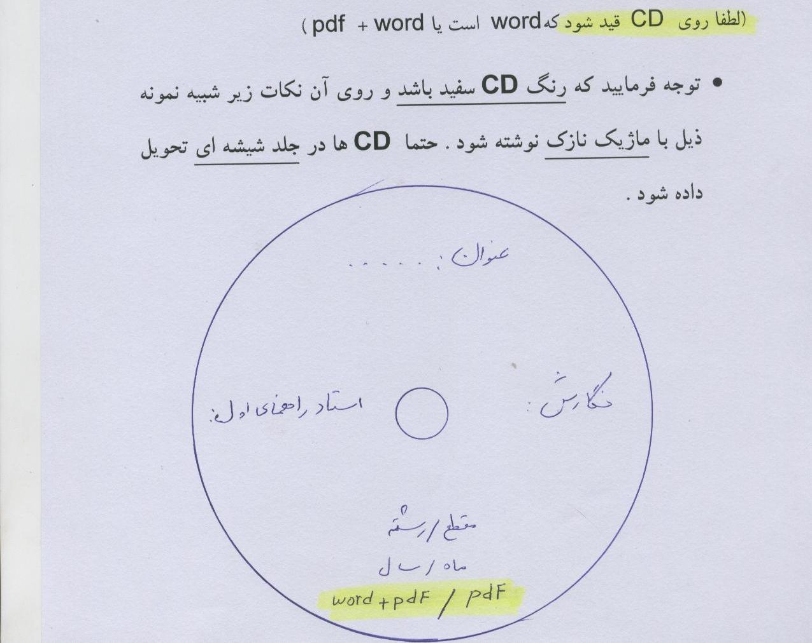

Please be aware that the library requires one of the CDs included a specific format as exemplified below.
- A CD should contain the full Word and PDF format of the dissertation
- A PDF file from the first page of the dissertation
- A PDF file from the Persian abstract
- A PDF file from the English abstract
Steps for Graduation
Follow the steps below to settle the account:
1- Postgraduate studies: Receiving the settlement form and presenting a CD number that includes the complete Word and PDF file of the dissertation and PDF of the dissertation abstract and getting a signature
2- Faculty Library: Presenting a binding volume and a CD number that includes the full Word and PDF file of the dissertation and a PDF file from the first page of the dissertation and a PDF file from the Persian abstract and a PDF file from the English abstract and getting a signature
3- Faculty research: Presenting a CD number that includes the PDF file and the complete PDF dissertation of abstract and getting a signature
4- Group manager: Presenting a CD number that includes the complete PDF file of the dissertation and the complete PDF dissertation of the dissertation abstract and getting a signature
5- Laboratory: Get a signature from the head of the laboratory or group manager
6- First Supervisor: Presenting a CD number that includes the complete PDF file of the dissertation and the full PDF of the dissertation, abstract of the dissertation and getting a signature (it should be mentioned that the first supervisor should be asked if they want a binding or not if If you want a bookbinder, you have to prepare a volume for them and then sign it)
7- Statistics Consultant: Provide a CD number that includes the full PDF file of the dissertation and the full PDF dissertation abstract and get a signature
8- Student Affairs: Get a signature and receive a debt status form
9- Going to the university and getting a signature from the research committee and the university disciplinary committee
10- Return the signed settlement form to postgraduate studies
Please note that after these steps, the graduate will send your transcripts to the university for graduation.

Writing guide for:
* On the Cover
1- The logo of the university should be completely in the middle and the size should be 3 × 3 cm.
2- The text of the University of Medical Sciences should be 5.5 cm from the top of the page and the margin should be 2 cm on both sides and its pen should be written with a black title of 20.
3- Rehabilitation School completely in the middle with black title 14 distances from the top edge of the paper 6.5
4- Thesis for ..... in the middle with black title 14 distance from the top edge of the paper 8 cm
5- Title with black title 20 distances from the top edge of the paper 11 cm
6- Thesis title with black title 18 distance from the top edge of the paper 12 cm
7- Supervisor with black headline 20 distances from the top edge of the paper 16 cm
8- Name and surname of the supervisor with black title 14 distance from the top edge of the paper 17 cm
9- Consulting professor with black title 20 distances from the upper edge of the paper 19 cm
10 Names and surnames of counseling professors with black headline 14 distance from the top edge of the paper 20 cm
11- Writing with a black title 14 distances from the top edge of the paper 24 cm
12- Name and surname of student writing with black title 14 distance from the top edge of the paper 25 cm
13- Academic year with black title 14 distances from the top edge of the paper 27 cm
14- Thesis number with black title pen 14
* Back cover (the whole text should be completely in the middle)
1- The logo of the university should be completely in the middle and should be 3 * 3 cm in size.
2- University text in Latin with Times Bold 20 and its distance from the top edge of the paper is 4.5 cm
3- Rehabilitation School with 18 Times Bold and its distance from the top edge of the paper is 6.5 cm
4- Thesis for ---- a 16 Times Bold and its distance from the top edge of the paper is 8 cm

5- Title with Times Bold 20 and its distance from the top edge of the paper is 10 cm
6- Thesis title with 18 Times Bold pen and its distance from the top edge of the paper is 11 cm
7- Supervisor with Times Bold 20 pen and its distance from the top edge of the paper is 17 cm
8- Name and surname of the supervisor with 18 Times Bold pen and its distance from the top edge of the paper 18 cm
9- Consulting teacher with Times Bold 20 pen and its distance from the top edge of the paper is 20 cm
10 - Name and surname of the consulting professor with 18 Times Bold pen and its distance from the top edge of the paper 21 cm
11- Writing with Times Bold 20 pen and its distance from the top edge of the paper is 25 cm
12- Name and surname of the researcher with Times Bold 18 and its distance from the top edge of the paper is 26 cm
13 - School year with 18 Times Bold pen and its distance from the top edge of the paper is 48 cm
Writing guide for the back cover:
* According to the cover, the back of the cover should be written in English and with the following observance.
Equivalent to Supervisor: Chief Advisor
Equivalent to receiving a master's degree / doctorate in physiotherapy: in Physiotherapy Thesis for MSc. / Ph.D. degree should be mentioned.
- The title should be in accordance with the sample provided with the size of the letters and their shape.
- Normally, the executive titles of the supervisor are not written on the cover and mentioning his scientific title (for example, doctor or engineer ...) is enough.
- There is no need to insert the symbol: or Colon, etc. on the cover, especially if they are separated based on importance, font size or shape.
- To insert the date, use the combination of month and year.

Shahid Beheshti University of Medical Scinces
Faculty of Rehabiltation

Thesis for M.Sc./ Ph.D. Degree in ………………

Title:

Chief Advisor:

Advisor:

By:

May 2023

Turning the Cover:
2- The title of the dissertation on the right and the name and surname of the student on the left and in Black Zar 14 font
Thesis text:
1- The margin of the dissertation should be formed from the right side 3.00, from the left side 2.00 from the top 3.00, from the bottom 2.50 cm, maximum 24-25 lines per page. The text font should be in Lotus thin point 14 and their title should be in black compost font 22 and the font should be in Latin letters using Times Medium 12

